The ANNUAL RODEO REUNION AND INDUCTION EVENT
Our Reunion and Induction Event is held every April in the Historic Stockyards, Fort Worth, Texas

2024 Inductee Event - Thursday-Saturday April 25-27, 2024
Fort Worth Stockyards National Historic District
Dear Friends of the Texas Rodeo Cowboy Hall of Fame,
We hope that you will consider supporting the Texas Rodeo Cowboy Hall of Fame and the 2024 Rodeo Reunion & Induction. Your sponsorship will be acknowledged in various ways throughout the year, as well as during the Induction.
We think this event will be a great opportunity to showcase your brand and support one of the most unique attractions in Fort Worth.
The Fort Worth Stockyards National Historic District has become a major attraction for locals and visitors with millions of national and international visitors annually. The Texas Rodeo Cowboy Hall of Fame is located in the historic Cowtown Coliseum which is on several tour routes. This along with the weekly rodeos and other events means that almost 500,000 people go through the Hall every year.
As a Sponsor, your support will be acknowledged during the Induction which was attended by over 800 cowboys, cowgirls and fans the past two years. This year’s induction will be broadcast to millions of homes across the country on The Cowboy Channel. Your support may also be recognized in the Hall and on our website and Facebook page. Please see the attached list of Sponsorship Opportunities for details.
The Texas Rodeo Cowboy Hall of Fame is recognized by the IRS as a 501(c)3 charity and a publicly supported museum under the name T.R.C. Hall of Fame & Associates, Inc. Our EIN number is 76- 0628258. If a W-9 form is required by you, it will be sent if requested.
Thank you in advance for your support,
Jack Ward, President

This year’s inductees are top notch
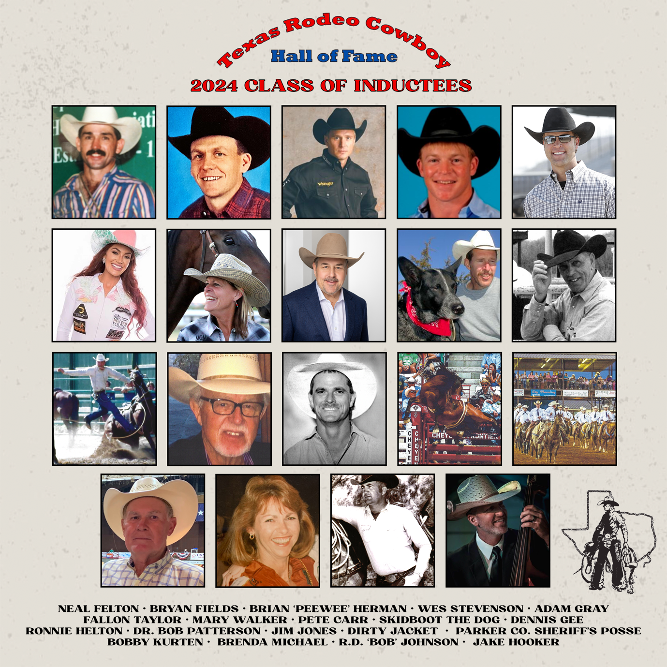

Texas Rodeo Cowboy Hall of Fame
Preserving the past – promoting the future

Sponsorship opportunities
The Texas Rodeo Cowboy Hall of Fame was founded in 1975 by Belton businessman and PRCA contestant, Johnny Boren. His vision and passion for rodeo and for the people of rodeo has allowed us to grow into an organization that has been able to pay tribute to over 390 cowboys and cowgirls. Their pictures and histories drape the walls of the Cowtown Coliseum in the Historic Fort Worth Stockyards. Honored are both the acclaimed and unsung heroes that made Texas rodeo what it is today.

The Texas Rodeo Cowboy Hall of Fame prides itself on honoring world champions and lesser-known trailblazers. Though some of their names may not be as recognizable as others, their impact on the culture and history of rodeo is appreciated by all. That is what makes rodeo and rodeo people so special and that is why the Texas Rodeo Cowboy Hall of Fame is dedicated to preserving the history and heritage of the Texas rodeo cowboy and cowgirl. Texas is known for many great accomplishments but being home to many of the best cowboys and cowgirls in the entire world is one of its highest honors.

The TRCHF holds an induction ceremony each year to recognize the contributions of the Texas Rodeo heroes and heroines. The induction welcomes 850 guests between the ceremony and golf tournament. In addition, the induction provides the opportunity to reunite history and memories of rodeo in one magical event. We at the TRCHF are proud to be home to these brilliant rodeo stories, places and the people who lived them.

We ask that you help us in this opportunity to protect the history of Texas Rodeo. Enclosed you will find the 2024 Sponsorship Packet.

Premiere Sponsor - $10,000
- Featured on Texas Rodeo Cowboy Hall of Fame website with a link to your website
- Recognition in induction program and on event presentation
- Premium reserved table for eight (8) with name recognition at induction
- Complimentary one year membership at the TRCHF for two people
- One page ad in the President’s letter sent out to over 400 members
- Facebook posts published twice monthly throughout the year with company or product highlights
- Gift bag from the TRCHF at your table upon arrival
____________________________________________________________________________

Major Sponsor - $5,000
- Featured on Texas Rodeo Cowboy Hall of Fame website with a link to your website
- Recognition in induction program and on event presentation
- Premium reserved table for eight (8) with name recognition at induction
- One page ad in the President’s letter sent out to over 400 members
- Facebook posts published once a month throughout the year
- Gift bag from the TRCHF at your table upon arrival

cowtown Sponsor - $2,500
- Recognition on website throughout the year
- Recognition in induction program and on event presentation
- Premium reserved table for eight (8) with name recognition at induction
- One page ad in the President’s letter sent out to over 400 members
- Facebook posts made once every other month
- Gift bag from the TRCHF at your table upon arrival
____________________________________________________________________________

Horizon Sponsor - $1,500
- Reserved table for six (6) with name recognition at induction
- Recognition in induction program and on event presentation
- Host two Horizon Honorees and their parents at your table
- Facebook posts made four times a year
____________________________________________________________________________

Arena director Sponsor - $1,000
- Reserved table for four at induction
- Recognition in induction program and on event presentation
- Facebook posts made twice a year
- Recognition on website
____________________________________________________________________________

Buckle Sponsor - $300
- Recognition in induction program and on event presentation

All tables and must RSVP and share attendee names with Ronda May prior to the induction ceremony, rondamay1@earthlink.net

Additional opportunities

AUCTION DONATIONS: Silent and Live Auction Marilyn Tadlock Ellis
Auction Chair | Phone: 940-765-8899 | Email: mktellis@hotmail.com

SCHOLARSHIP DONATIONS: $100.00 AND UP Todd Kercheval
Scholarship Chair | Phone: 817-296-9575 | Email: todd@toddkercheval.com

GOLF TOURNAMENT OPPORTUNITIES: Ronda May or Jack Ward
Phone: 817-832-3117

SPONSORSHIP OPPORTUNITIES: Hub Baker
Sponsorship Committee Chair | Phone: 817-233-8491 | Email: hub@hubbaker.com
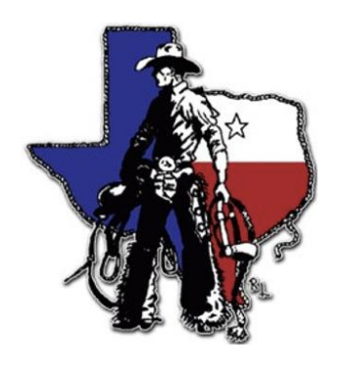

Texas Rodeo Cowboy Hall of Fame
Administrative Office
P.O. Box 3582 , San Angelo 76902
817-624-7963

